

**A PROJECT REPORT ON**

**“ONLINE JOB PORTAL”**

Submitted by

**Miss Divya Koli & Miss Shivani Jagtap**

SY. BBA(CA)

YEAR- 2023-2024

**G.H RAISONI COLLEGE OF ARTS, COMMERCE & SCIENCE**

**Wagholi, Pune-412207.**

Under the Guidance of

**Prof. Vishal Waghole Sir.**

  
**G.H RAISONI COLLEGE OF ARTS, COMMERCE & SCIENCE.**

**WAGHOLI, PUNE – 412207**

**CERTIFICATE**

This is to clarify that

**“Divya Koli” Roll no. BCAM223** and **“Shivani Jagtap” Rollno Roll no. BCAM275** Of

**SY.BBA(CA)** has satisfactorily completed their project work under the subject

**“Online Job Portal”** for the academic year 2023-2024.

PROJECT GUIDE

Internal Examiner External Examiner

H.O.D Principal

**ACKNOWLEDGEMENT**

It is event of great pleasure in submitting the report entitled **“ONLINE JOB PORTAL”.**

I extent out a sincere and heartfelt thanks to our esteemed guide, **Prof. Vishal Waghole** Sir for providing us with the right guidance and advice, which helps me to take up the responsibilities with courage and determination.

Lastly , I like to thank all my supporters who have motivated me to fulfill project before the timeline.

**Projected By:**

**DIVYA KOLI & SHIVANI JAGTAP**

**INDEX:**

|  |  |  |
| --- | --- | --- |
| **Sr. No** | **CONTENT** | **Page No.** |
| **1** | **Introduction** |  |
| **2** | **Objective** |  |
| **3** | **Literature Survey** |  |
| **4** | **SRS** |  |
| **5** | **Requirement Specification** |  |
| **6** | **Feasibility Study** |  |
| **7** | **Project Design** |  |
| **8** | **DFD Diagram** |  |
| **9** | **ER Diagram** |  |
| **10** | **Design & Screenshots** |  |
| **11** | **Implementation** |  |
| **12** | **Testing** |  |
| **13** | **Future Scope** |  |
| **14** | **Conclusion** |  |

**INTRODUCTION:**

In today's fast-paced digital age, the traditional methods of job hunting are evolving. Welcome to “Online Job Portal” Project, a cutting-edge online job portal designed to streamline the employment process for both employers and job seekers alike.

“Online Job Portal” Project serves as a centralized hub where companies can post job openings, and qualified candidates can easily search and apply for positions tailored to their skills and preferences. Our platform leverages advanced algorithms and intuitive user interfaces to deliver a seamless experience, empowering users to efficiently navigate the competitive job market.

With “Online Job Portal” Project, employers gain access to a vast pool of talented individuals, enabling them to find the perfect match for their job requirements quickly and effectively. Meanwhile, job seekers can explore a wide range of career opportunities, connect with prospective employers, and take their professional aspirations to new heights.

Join us as we redefine the way people find and fill job positions. Whether you're a job seeker ready to embark on your next career journey or an employer seeking top talent, “Online Job Portal” Project is here to simplify the process and facilitate meaningful connections. Let's build a future where finding the perfect job is easier than ever before.

**Objective:**

The objectives for an online job portal project typically revolve around providing value to both job seekers and employers while achieving business goals. Here are some common objectives for such a project:

1. **Facilitate Efficient Job Matching**: Enable job seekers to find relevant job opportunities quickly and easily based on their skills, experience, and preferences, while helping employers identify suitable candidates efficiently.
2. **Enhance User Experience**: Create a user-friendly interface that simplifies the job search and application process for job seekers and provides intuitive tools for employers to manage job listings and candidate applications.
3. **Expand Job Market Reach**: Connect job seekers with a diverse range of employment opportunities from local, national, and international companies, expanding their job market reach and increasing employment prospects.
4. **Foster Networking and Connections**: Provide features that enable job seekers to network with industry professionals, mentors, and peers, as well as allowing employers to engage with potential candidates through networking events, job fairs, and communication channels.
5. **Promote Diversity and Inclusion**: Actively promote diversity and inclusion by offering equal opportunities to candidates from diverse backgrounds and encouraging employers to adopt inclusive hiring practices.
6. **Drive Business Growth**: Support employers in attracting top talent, reducing recruitment costs, and improving workforce retention, ultimately contributing to their business growth and success.
7. **Offer Data Insights and Analytics**: Utilize data analytics to provide insights into job market trends, candidate preferences, and recruitment effectiveness, empowering employers to make informed hiring decisions and optimize their recruitment strategies.
8. **Ensure Security and Privacy**: Implement robust security measures to protect user data and privacy, fostering trust and confidence among both job seekers and employers.

**Project Scope:**

Defining the project scope for an online job portal project is crucial to ensure that the development team understands the deliverables, features, and functionalities that need to be included. Here's a breakdown of the project scope for an online job portal:

1. **User Roles and Authentication**: Define user roles such as job seekers, employers, and administrators, and implement authentication mechanisms to ensure secure access to the portal.
2. **Job Search and Filtering**: Enable job seekers to search for jobs based on criteria such as location, industry, job title, and keywords, with advanced filtering options to refine search results.
3. **Job Posting and Management**: Allow employers to post job openings, including job descriptions, requirements, and application deadlines, and provide tools for managing and editing job listings.
4. **Application Management**: Implement features for job seekers to apply for jobs directly through the portal, track application statuses, and manage their application history.
5. **Resume/CV Management**: Enable job seekers to upload and manage their resumes/CVs, and provide tools for employers to review and filter candidate resumes/CVs efficiently.
6. **Communication Tools**: Integrate messaging or email functionalities to facilitate communication between job seekers and employers, including sending application status updates and scheduling interviews.
7. **Profile Management**: Allow users to create and manage their profiles, including personal information, work experience, education, skills, and preferences.
8. **Notifications and Alerts**: Implement notification systems to alert users about new job postings, application status changes, messages from employers, and other relevant updates.
9. **Analytics and Reporting**: Include analytics tools to track key metrics such as job listing views, application rates, and user engagement, and generate reports to provide insights for employers and administrators.
10. **Mobile Responsiveness**: Ensure that the portal is optimized for mobile devices, allowing users to access and use the platform seamlessly on smartphones and tablets.

**Literature Survey:**

|  |  |  |  |
| --- | --- | --- | --- |
| **Study Title** | **Authors** | **Year** | **Key Findings** |
| “Design and Development of Online Job Portal System” | A.Kumar,  S. Gupta | 2017 | Proposed a comprehensive system architecture for an online job portal incorporating features such as job research, resume management, and application tracking. |
| "A Comparative Study of Existing Online Job Portals" | B. Sharma, C. Patel | 2019 | Analyzed popular online job portals to identify key features, usability issues, and user satisfaction levels. |
| “Enhancing User Experience in Online Recruitment Systems" | X. Zhang, Y. Li | 2020 | Investigated usability improvements for online job portals, including intuitive search interfaces, personalized recommendations, and mobile optimization. |
| "Security Challenges in Online Job Portals" | D. Singh, F. Khan | 2018 | Explored security vulnerabilities in online job portals and proposed strategies to mitigate risks such as data breaches and fraudulent job postings. |
| "Utilizing Data Analytics for Recruitment Decision Making" | E. Chen, G. Wang | 2021 | Examined the role of data analytics in recruitment processes, highlighting the importance of leveraging data insights for candidate screening and talent acquisition. |

**Software Requirement Specification (SRS) for Online Job Portal**

**1. Introduction**

**1.1 Purpose**

* **Purpose**: Explain the purpose of the SRS document, which is to define the requirements for the development of the online job portal.
* **Scope**: Define the scope of the project, including what the online job portal will and will not include.
* **Definitions, Acronyms, and Abbreviations**: Provide a list of terms, acronyms, and abbreviations used throughout the document.
* **References**: Include any references to other documents or resources that are relevant to the project.
* **Overview of the Document**: Provide a brief overview of the contents of the SRS document.

**1.2 Overall Description**

* **Product Perspective**: Describe the context of the online job portal within the larger system, including any interfaces with external systems.
* **Product Functions**: List the main functions of the online job portal, such as job searching, job posting, resume management, and user registration.
* **User Classes and Characteristics**: Define the different types of users who will interact with the system (e.g., job seekers, employers, administrators) and describe their characteristics and roles.
* **Operating Environment**: Describe the environment in which the online job portal will operate, including hardware and software requirements.
* **Design and Implementation Constraints**: Identify any constraints or limitations that will impact the design and implementation of the system.
* **Assumptions and Dependencies**: List any assumptions made during the development process and identify any dependencies that the system has on external factors.

**1.3 Specific Requirements**

**External Interface Requirements:**

* **User Interfaces**: Describe the interfaces that users will interact with, including web pages, forms, and dashboards.
* **Hardware Interfaces**: Specify any hardware devices that the system will interact with, such as servers or databases.
* **Software Interfaces**: Identify any third-party software or APIs that the system will integrate with.
* **Communication Interfaces**: Describe how the system will communicate with external systems or services.

**Functional Requirements:**

Define the specific functions and features of the online job portal, including:

* Job seeker functionalities (e.g., job search, resume upload, application tracking)
* Employer functionalities (e.g., job posting, candidate search, application management)
* Administrator functionalities (e.g., user management, content moderation, reporting)
* System administration functionalities (e.g., system configuration, backup and recovery)

**Non-Functional Requirements**

Specify the qualities or attributes that the system must have, such as:

* Performance requirements (e.g., response time, throughput)
* Security requirements (e.g., authentication, data encryption)
* Usability requirements (e.g., accessibility, user interface design)
* Reliability requirements (e.g., system uptime, error handling)
* Scalability requirements (e.g., ability to handle increasing user loads)

**Requirenment Specification:**

• **Functional Requirements**:

* **User Registration and Authentication:**
  + Users should be able to register for an account with their email address or social media accounts.
  + Upon registration, users should receive a confirmation email or verification code to activate their account.
  + Users should be able to log in securely using their credentials.
* **Job Search and Filtering**:
  + Job seekers should be able to search for jobs based on various criteria such as location, industry, job title, salary range, and keywords.
  + Advanced search filters should be available to refine search results.
* **Job Posting and Management**:
  + Employers should be able to post job openings, including job descriptions, requirements, and application deadlines.
  + Employers should have the ability to edit, pause, or delete job postings as needed.
* **Application Management**:
  + Job seekers should be able to apply for jobs directly through the portal by submitting their resumes/CVs and cover letters.
  + Employers should be able to review and manage job applications, including shortlisting candidates, scheduling interviews, and sending notifications to applicants.
* **Resume/CV Management**:
  + Job seekers should be able to create and manage their profiles, including uploading and updating their resumes/CVs, work experience, education, skills, and preferences.
  + Employers should be able to view and download candidate resumes/CVs.
* **Communication Tools**:
  + Messaging or email functionalities should be available for communication between job seekers and employers, allowing for inquiries, interview scheduling, and status updates.
* **User Profile Management**:
  + Users should be able to update their profiles, including personal information, contact details, and preferences.
* **Notifications and Alerts**:
  + Users should receive notifications and alerts about new job postings, application status changes, messages from employers, and other relevant updates.
* **Reporting and Analytics**:
  + The system should provide analytics and reporting tools for tracking key metrics such as job listing views, application rates, and user engagement.
* **Administrator Functions**:
  + Administrators should have access to tools for managing users, job listings, content moderation, and system settings.

• **Non-Functional Requirements**:

* **Performance**:
  + The system should be responsive and have fast loading times, even during peak usage periods.
  + Response times for search queries, page loads, and form submissions should be optimized.
* **Security**:
  + User data should be encrypted during transmission and storage.
  + Robust authentication and authorization mechanisms should be implemented to prevent unauthorized access.
* **Scalability**:
  + The system should be able to handle a large number of concurrent users and job listings without degradation in performance.
* **Reliability**:
  + The system should be highly available and reliable, with minimal downtime and data loss.
* **Usability**:
  + The user interface should be intuitive, easy to navigate, and accessible on multiple devices (e.g., desktops, tablets, smartphones).
  + Accessibility features should be implemented to ensure usability for users with disabilities.
* **Compliance**:
  + The system should comply with relevant laws and regulations, such as data protection regulations (e.g., GDPR, CCPA) and accessibility standards (e.g., WCAG).

**Feasibility Study:**

* **Technical Feasibility**:
* **System Requirements**: Evaluate whether the required technology infrastructure (hardware, software, networks) is available or can be feasibly developed or procured.
* **Development Resources**: Assess the availability of skilled developers, designers, and other technical personnel required for building and maintaining the online job portal.
* **Integration with Existing Systems**: Determine whether the online job portal can integrate with existing systems and databases within the organization or external systems such as job boards or social media platforms.
* **Economic Feasibility:**
* **Cost-Benefit Analysis**: Estimate the costs associated with developing, deploying, and maintaining the online job portal compared to the potential benefits and returns on investment (ROI).
* **Revenue Model**: Identify potential revenue streams for the online job portal, such as subscription fees for employers, premium job listings, advertising revenue, or affiliate partnerships.
* **Market Demand**: Analyze the demand for online job portals in the target market and assess the potential market size, growth trends, and competitive landscape.
* **Operational Feasibility**:
* **User Acceptance**: Evaluate whether users (job seekers, employers, administrators) will find the online job portal useful, intuitive, and easy to use.
* **Business Processes Integration**: Determine whether the online job portal aligns with existing business processes and workflows within the organization or if it requires significant changes or adaptations.
* **Training and Support**: Assess the feasibility of providing training and support to users to ensure smooth adoption and usage of the online job portal.
* **Legal and Regulatory Feasibility:**
* **Data Protection and Privacy**: Ensure compliance with relevant data protection regulations (e.g., GDPR, CCPA) by implementing appropriate measures to protect users' personal information and privacy rights.
* **Intellectual Property**: Assess any potential legal issues related to intellectual property rights, such as copyright infringement or trademark violations, especially if using third-party content or technology.
* **Employment Laws**: Consider legal requirements related to employment laws, nondiscrimination policies, and fair hiring practices that may impact the operation of the online job portal.
* **Schedule Feasibility**:
* **Timeline**: Evaluate whether the project can be completed within the desired timeframe, considering factors such as development, testing, deployment, and any regulatory or approval processes.
* **Milestones and Deliverables**: Define key milestones and deliverables for the project and assess the feasibility of meeting them within the specified schedule.
* **Risk Assessment**:
* Identify potential risks and challenges that may affect the success of the online job portal project, such as technical issues, market competition, changes in regulations, or economic uncertainties.
* Develop risk mitigation strategies to address and minimize the impact of identified risks on the project's outcomes.

**Project Design:**

• **System Architecture**:

* **Client-Server Architecture**: Implement a client-server architecture where the client (web browser) interacts with the server-side application to perform various functions.
* **Three-Tier Architecture**: Divide the system into three layers: presentation layer (user interface), application layer (business logic), and data layer (database).
* **Scalability and High Availability**: Design the system to be scalable and highly available to handle increasing user traffic and ensure uninterrupted access to the portal.

• **User Interface Design**:

* **Responsive Design**: Create a responsive and mobile-friendly user interface that adapts to different screen sizes and devices.
* **Intuitive Navigation**: Design an intuitive navigation structure with clear menus, categories, and search functionalities to help users find relevant job listings quickly.
* **User-Friendly Forms**: Develop user-friendly forms for registration, job search, job application, and profile management, with clear labels, error messages, and validation checks.
* **Visual Design**: Use a clean and modern visual design with consistent typography, color schemes, and imagery to enhance the user experience and brand identity.

**BELOW IS THE DETAIL DFD DIAGRAM FOR ONLINE SHOPPING PORTAL.**

**LEVEL 0** 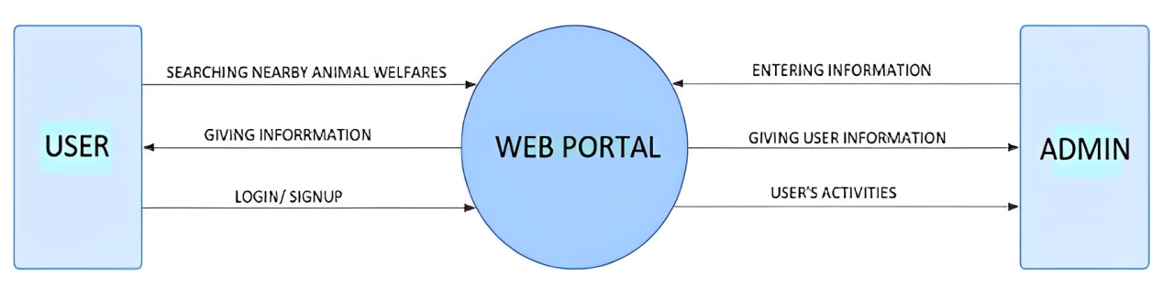

**LEVEL 1**

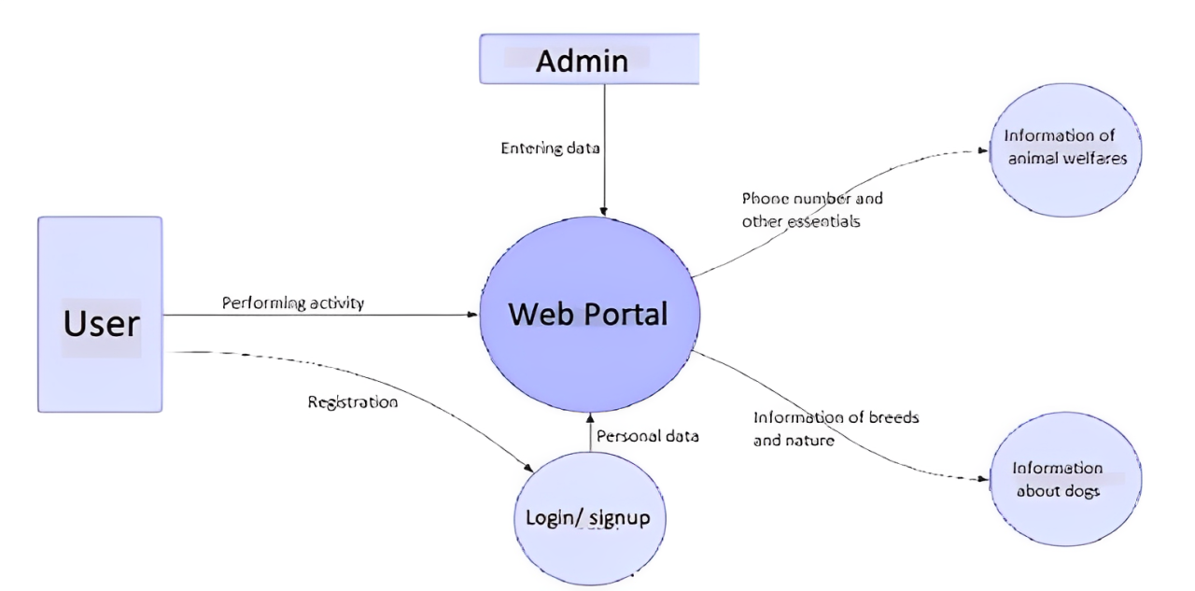

**USE CASE DAIGRAM :**

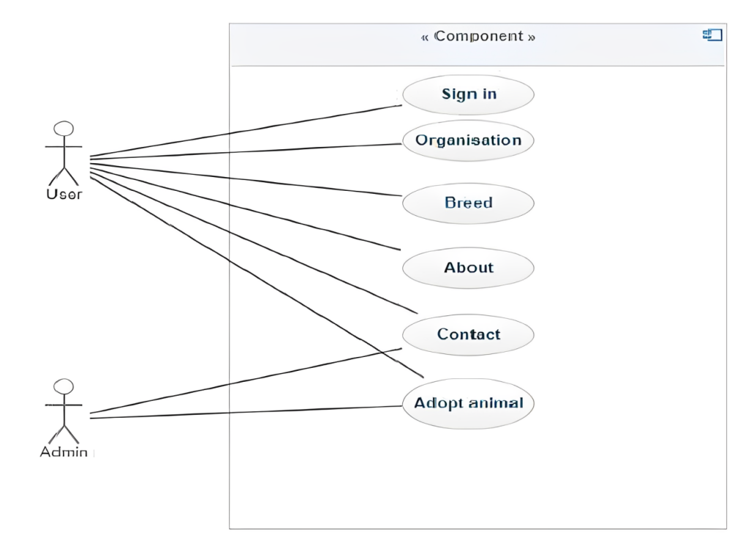

**ER DIAGRAM FOR ONLINE SHOPPING PORTAL.**

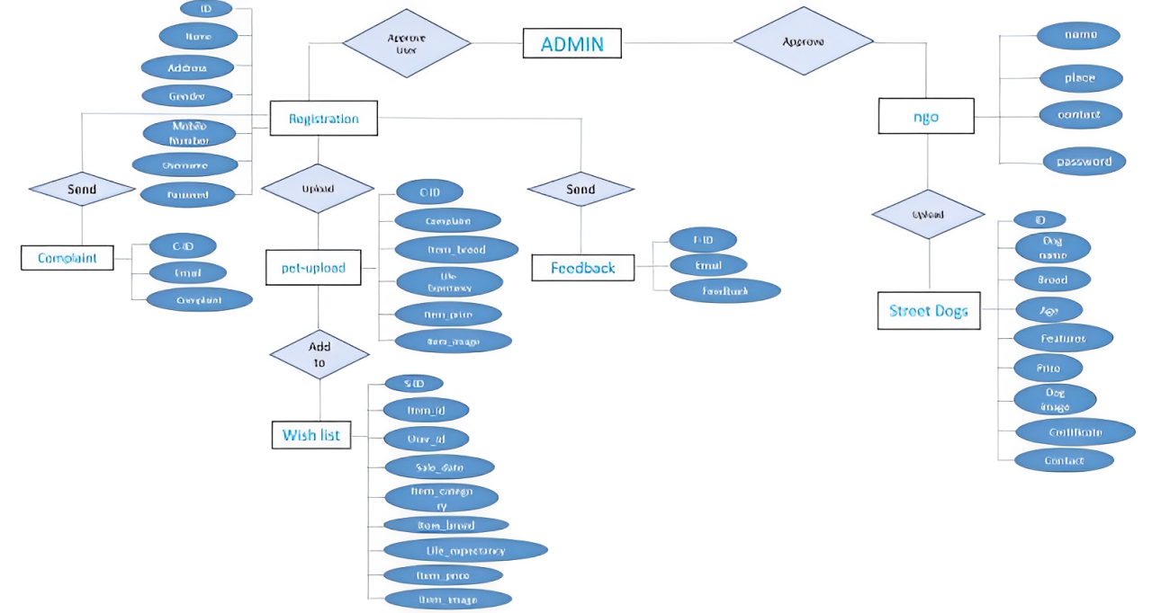

**Feasibility Study :**

1**. Technical Feasibility:**

- Standard hardware and software requirements.

- Feasible integration with AI, geolocation, and social media services.

**2. Operational Feasibility:**

- User-friendly interface requiring minimal training.

- Low maintenance requirements and scalable architecture.

3. **Economic Feasibility:**

- Cost-benefit analysis favors project investment.

- Projected ROI justifies initial costs.

4. **Legal Feasibility:**

- Compliance with data protection regulations.

- Respect for intellectual property rights.

5. **Schedule Feasibility:**

- Realistic project timeline.

- Availability of skilled resources for timely completion.

**List of Figures:**

1. Home Page
2. About Us
3. Contact
4. Service
5. Blogs

**1.HOME PAGE:**

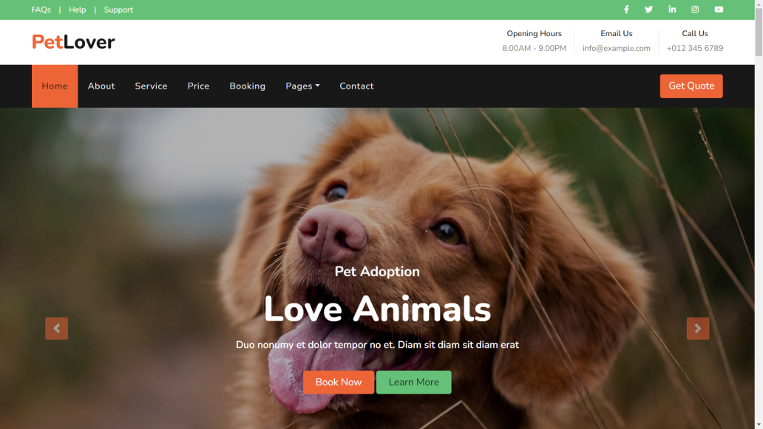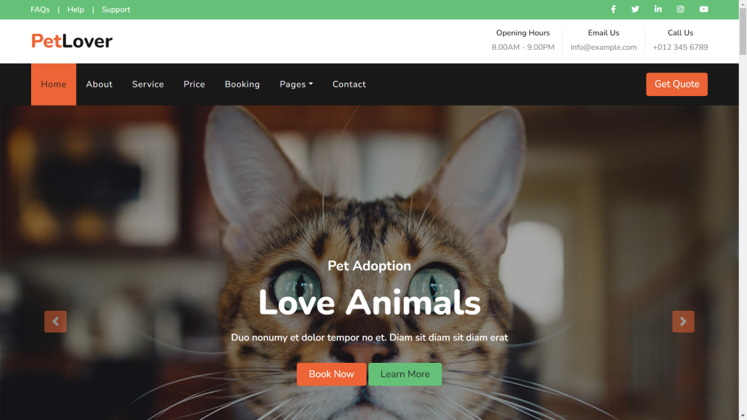

**2.About Us:**

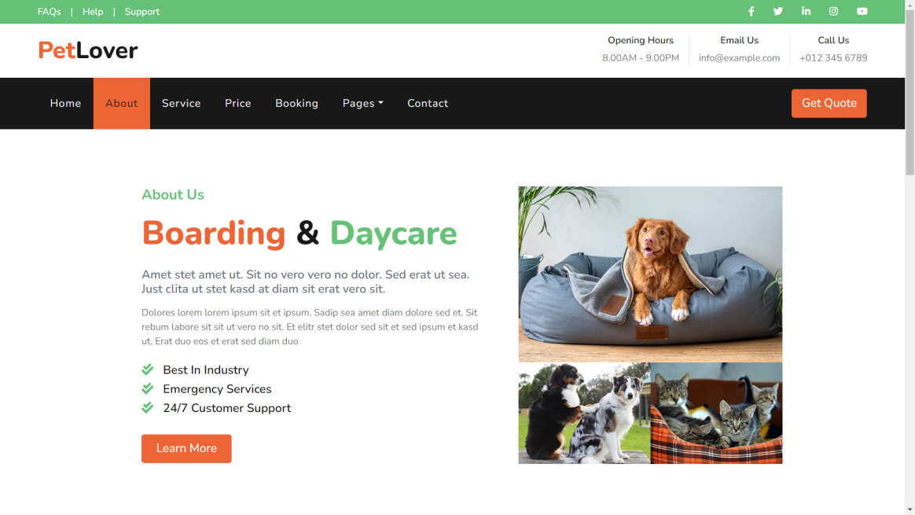

**3.Contact:**

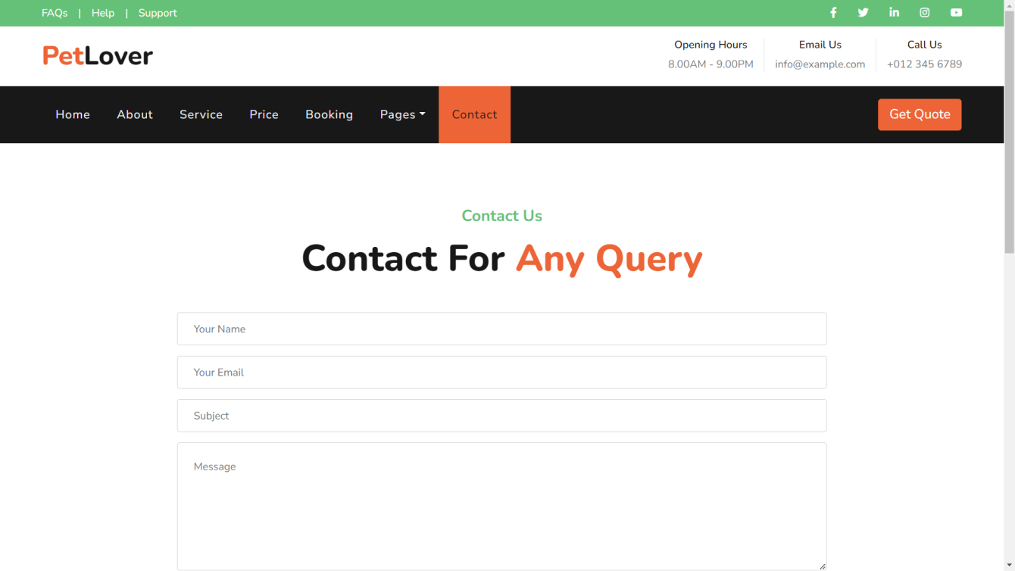

**4. Team Bio:**

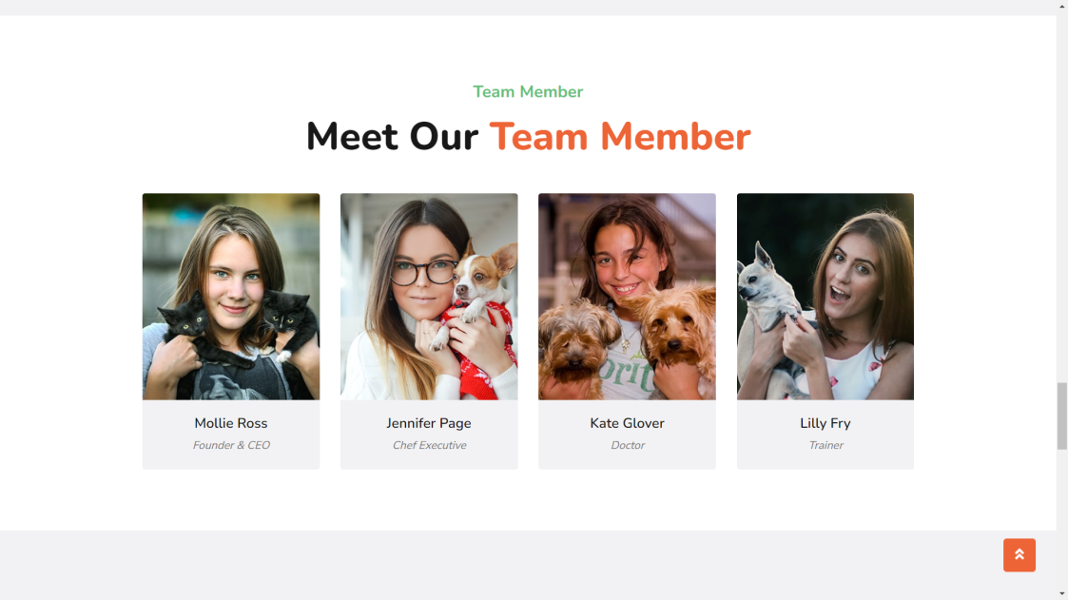

**5.Feedback:**

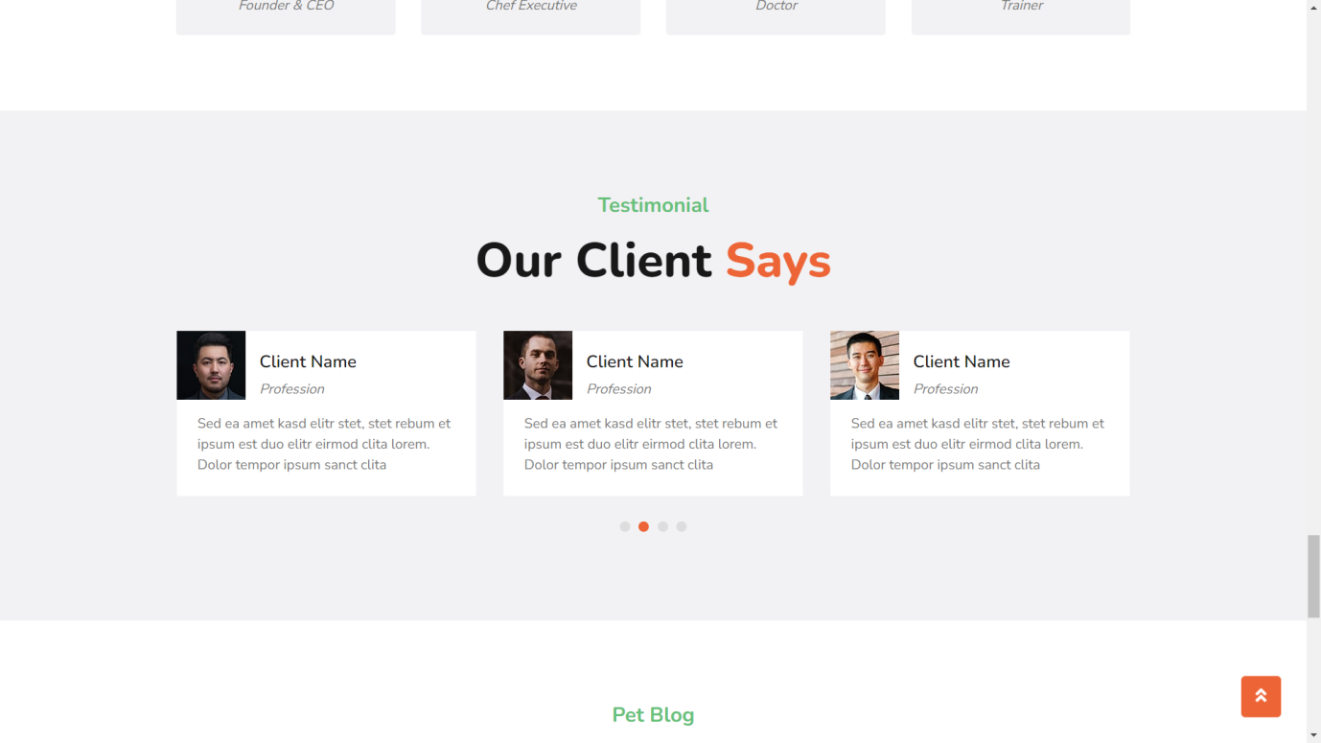

**6.Blogs and Posts:**

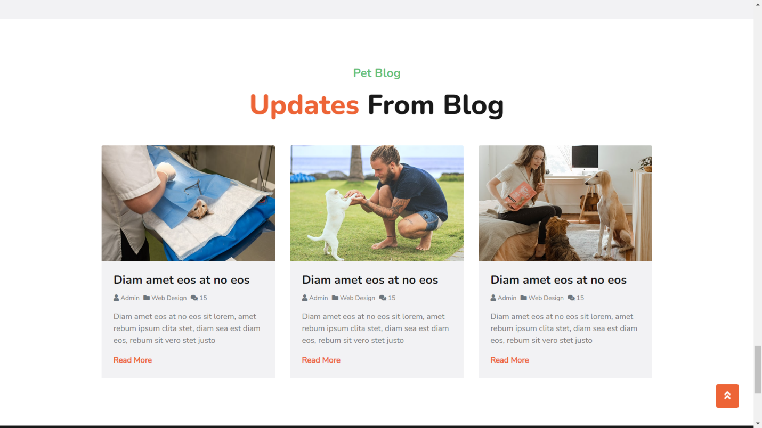

**7. Footer:**

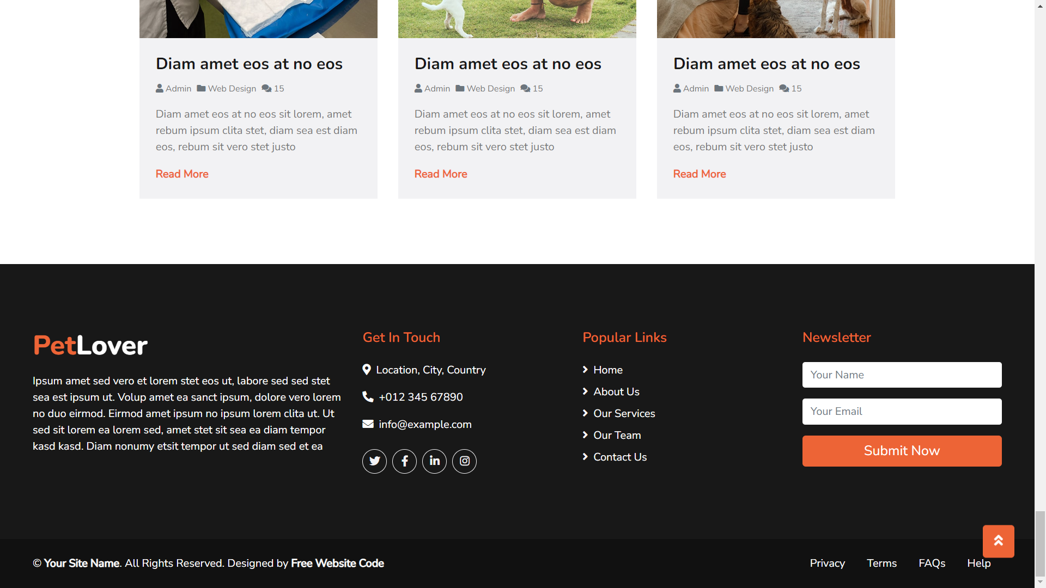

**Future Scope of the Pet Adoption Website Project**

1. Enhanced AI Chatbot: Integrate advanced natural language processing (NLP) techniques to improve the chatbot's capabilities in providing pet care advice and answering user queries more intelligently.

2. Geolocation Services: Implement geolocation features to help users find pets or adoption centers nearby based on their current location, enhancing the adoption process and user experience.

3. Integration with Adoption Agencies: Collaborate with local animal shelters and adoption agencies to streamline the adoption process through the website, allowing users to directly connect with adoption centers and complete adoption formalities online.

4. Mobile Application Development: Develop a companion mobile app for the pet adoption website, providing users with a seamless and mobile-friendly experience for browsing pets, receiving notifications, and accessing chatbot services on-the-go.

5. Social Media Integration: Enhance social media integration by allowing users to share their pet adoption stories, experiences, and photos on social platforms directly from the website, fostering a community of pet lovers.

6. E-commerce Integration: Introduce e-commerce features to the website, enabling users to purchase pet supplies, accessories, and services conveniently, thereby generating additional revenue streams.

7. Data Analytics and Personalization: Implement data analytics tools to analyze user behavior, preferences, and adoption trends, allowing for personalized recommendations and targeted marketing campaigns.

**Conclusion**

The pet adoption website project aims to create a comprehensive platform for pet lovers to connect, adopt pets, and access valuable pet care resources. By incorporating advanced technologies such as AI chatbots, geolocation services, and social media integration, the project enhances user engagement and simplifies the pet adoption process.

Moving forward, the project has significant potential for expansion and improvement, including the development of a mobile app, integration with adoption agencies, and e-commerce functionalities. These future enhancements will further enrich the user experience, promote responsible pet ownership, and contribute positively to the welfare of pets and their adoptive families.